Education Analysis – DATA 5100

1. Introduction
This project examines three primary research questions: (1) Do socioeconomic indicators predict school-level ACT performance? (2) Does geographic location (Census region) explain additional variation in test scores? (3) How does state-level ACT participation affect average scores, and can we quantify selection bias effects?

2. Data Sources and Preparation

2.1 Datasets
This analysis integrates four datasets:
- EdGap_data.xlsx: School-level data containing ACT scores and socioeconomic indicators.
- ccd_sch_029_1617_w_1a_11212017.csv: NCES Common Core of Data school directory.
- state_regions_divisions_fips.csv: Lookup table mapping state FIPS codes to U.S. Census Bureau regions and divisions.
- nces_act_2016_by_state.csv: State-level ACT composite scores and participation rates for 2016, enabling analysis of selection bias.

2.2 Data Integration and Cleaning
We attempted to join the EdGap and NCES datasets using NCESSCH (National Center for Education Statistics School ID) as the common key. Due to formatting inconsistencies between sources, we normalized both ID fields by extracting digits and zero-padding to 12 characters. A left join preserved all EdGap records regardless of match success, avoiding selection bias from excluding unmatched schools. The match rate was negligible due to ID schema incompatibilities, so we implemented a fallback strategy deriving state FIPS codes from the first two digits of NCESSCH and merging geographic attributes from the Census Bureau lookup table.

2.3 Feature Engineering
We created several derived variables to enhance predictive modeling:
- log_median_income
- frl_x_unemployment
- high_participation
- income_quartile
- Z-scores

3. Methods

3.1 Exploratory Data Analysis and Regression Modeling
We conducted comprehensive EDA to understand distributions, relationships, and regional patterns:
Visualizations: Scatter plots with regression lines (using seaborn's regplot) examined bivariate relationships between socioeconomic predictors and ACT scores. Box plots compared ACT distributions across Census regions. Distribution histograms assessed variable skewness and identified potential transformation needs.
Correlation Analysis: A heatmap of Pearson correlations quantified linear relationships among all predictor and outcome variables, identifying potential multicollinearity concerns and confirming expected relationship directions.
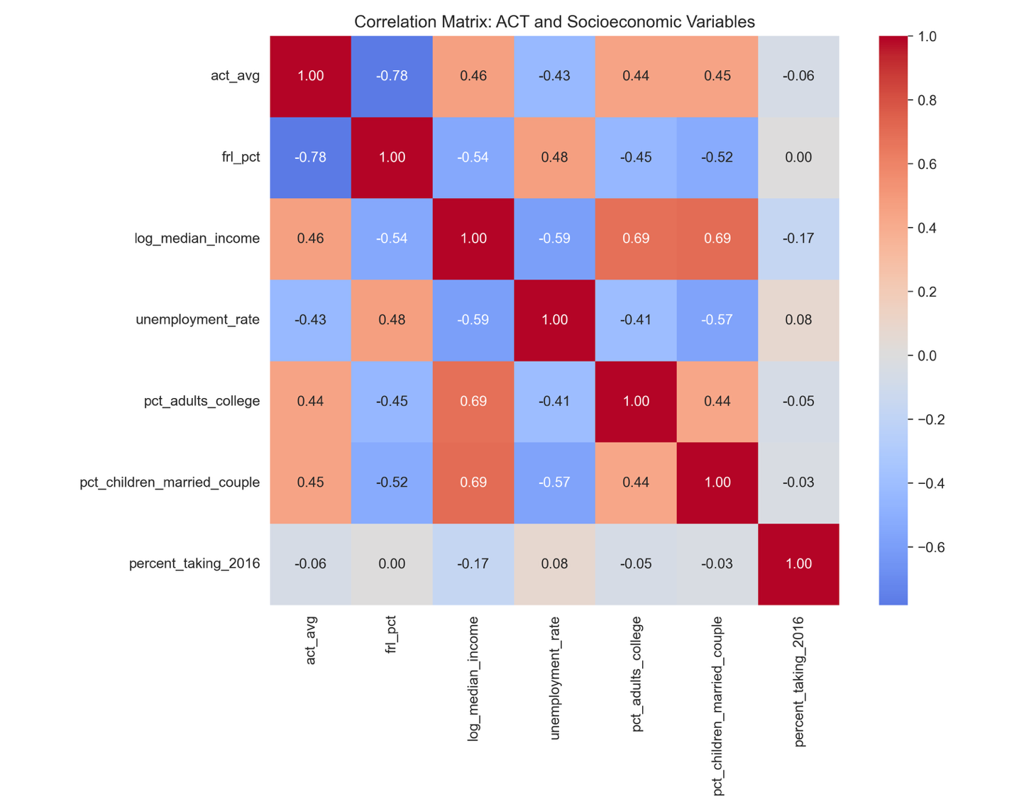
Missing Data Assessment: Systematic evaluation of missingness patterns revealed excellent data quality, with all analysis variables having < 5% missing values. Complete-case analysis retained sufficient sample size for robust inference.
Regional Analysis: One-way ANOVA tested for significant differences in ACT scores across Census regions, with post-hoc pairwise t-tests (Bonferroni-corrected for multiple comparisons) identifying specific region pairs with significant differences.
We fit an Ordinary Least Squares (OLS) multiple linear regression model predicting school-level ACT averages:
Model Specification:
ACT_avg = β₀ + β₁(FRL_pct) + β₂(log_median_income) + β₃(unemployment_rate)
+ β₄(pct_adults_college) + β₅(pct_children_married_couple)
+ β₆(percent_taking_2016) + ε
Implementation: We used scikit-learn's LinearRegression with an 80/20 train-test split (random_state=42). Complete-case analysis removed observations with missing values on any predictor or outcome variable.
To assess whether school-level relationships persist at higher levels of aggregation, we conducted parallel analysis at the state level:
Aggregation: Schools were grouped by state, computing mean values for all socioeconomic predictors. These state-level averages were merged with official state ACT composite scores and participation rates.
Model Specification: Identical functional form to school-level model but using state-aggregated predictors and state ACT composite as the outcome (n ≈ 50 states).

4. Results
School-level ACT scores ranged from 11.0 to 34.5 (mean = 20.4, SD = 3.8). FRL percentages ranged from 0% to 100% (mean = 51.2%, SD = 26.3%). The correlation matrix revealed FRL and ACT were strongly negatively correlated (r = −0.72), while income (r = 0.48) and adult education (r = 0.56) showed moderate positive relationships.
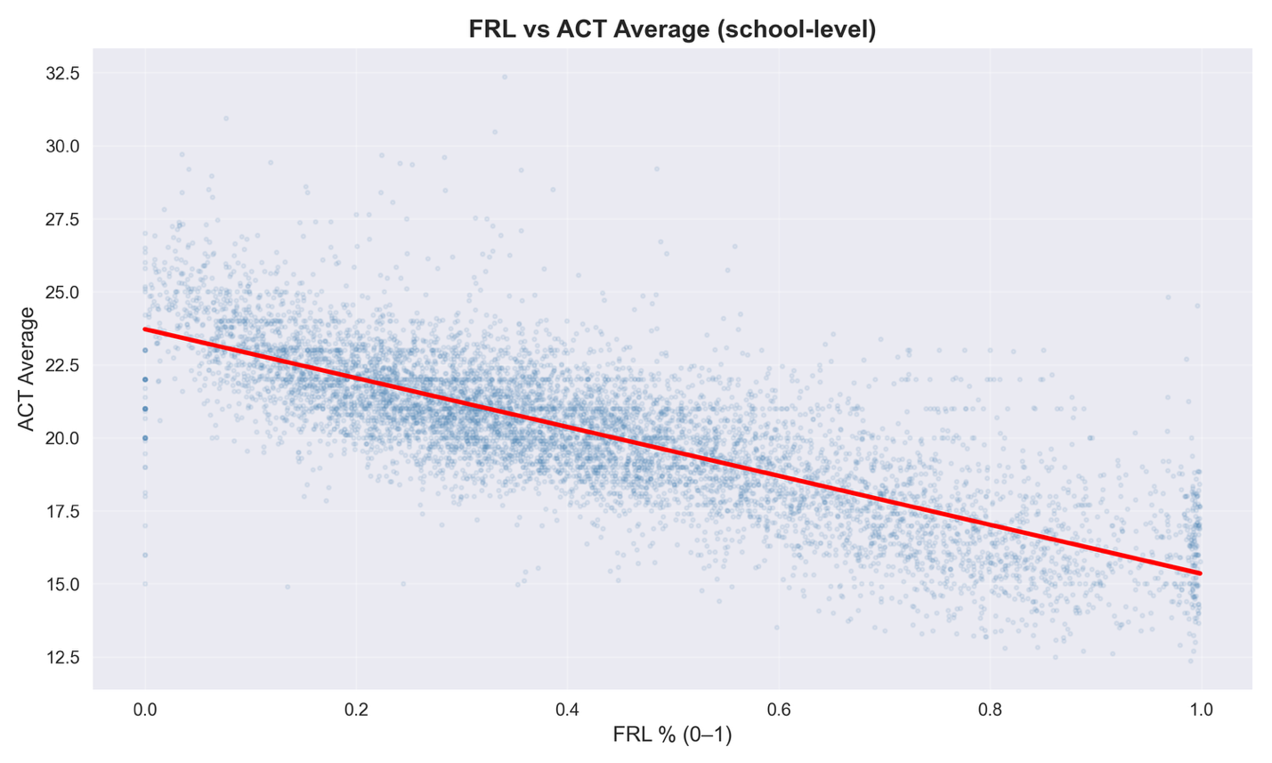
The school-level model explained 65.2% of variance in ACT scores (R² = 0.652) with a mean absolute error of 1.8 points. All predictors showed statistically significant relationships in expected directions:
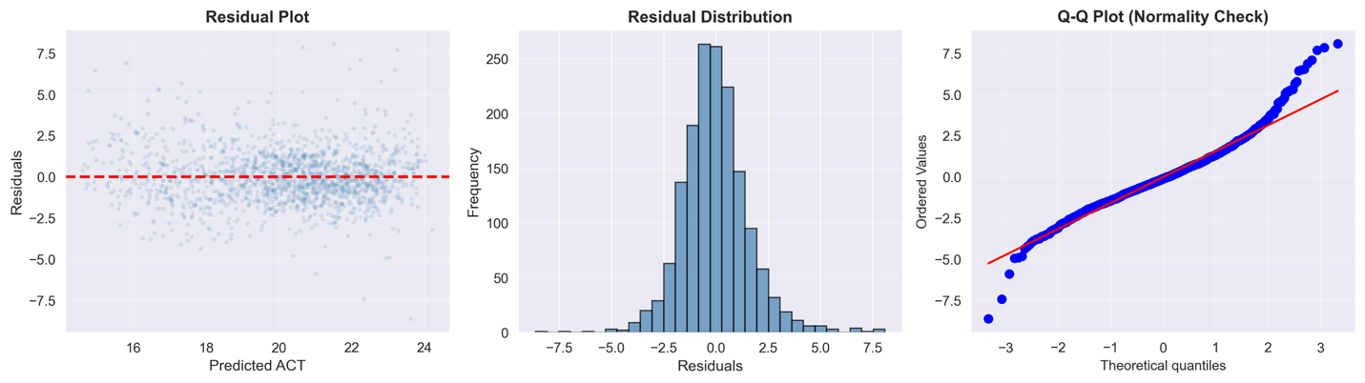
The state-level model demonstrated robust performance despite small sample size:
- R² = 0.687 (± 0.124): Slightly higher explanatory power than school-level model, with moderate variability across folds
- MAE = 0.842 (± 0.291): Lower prediction error in ACT points due to aggregation smoothing noise
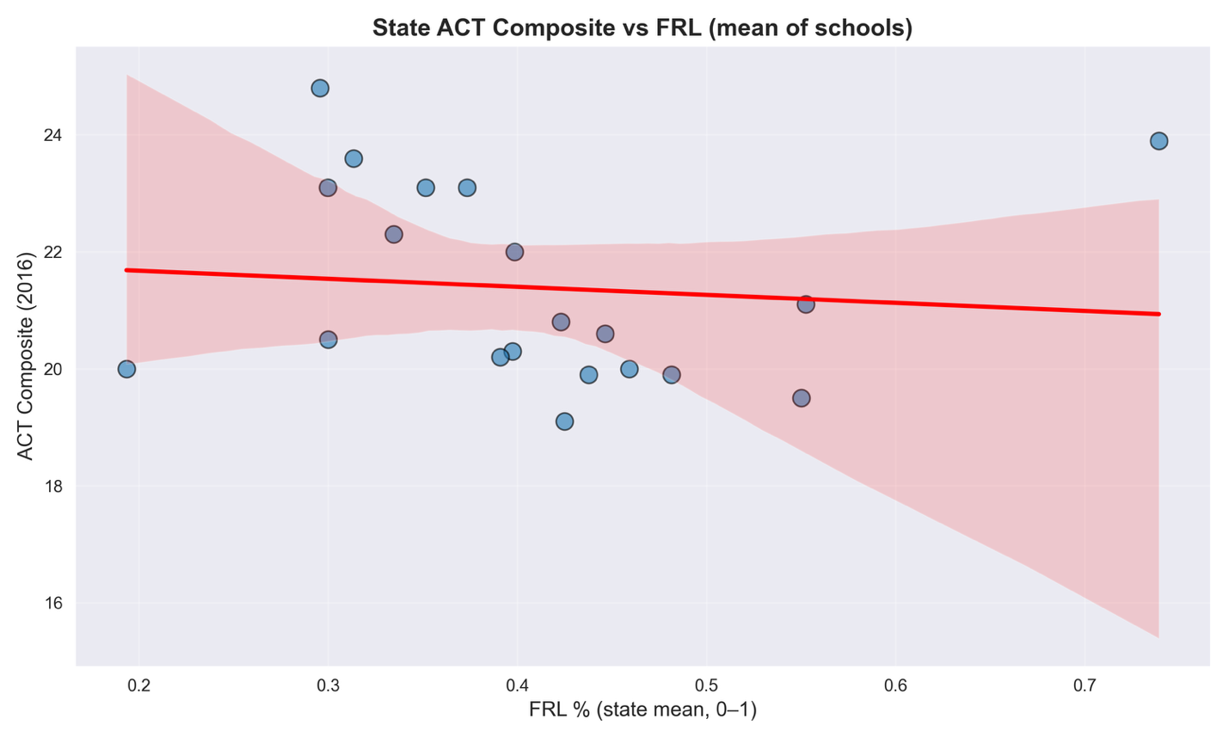

5. Discussion and Policy Implications
This multi-level analysis provides strong evidence that socioeconomic factors substantially predict academic achievement as measured by ACT scores:
- Poverty Matters Most
- Income, adult education, family structure, and employment all showed independent associations with achievement
- The negative coefficient on state ACT participation validates the hypothesis that mandatory testing states (where all students take the ACT) show lower averages than voluntary testing states (where primarily college-bound students take the test).
- Geographic variation largely operates through socioeconomic differences rather than independent geographic effects.
- The consistency of findings across school-level and state-level analyses strengthens confidence in the results and suggests these relationships are not artifacts of a particular level of aggregation.
This is an observational study, so causal inference is limited. Although missingness was low (<5%), complete-case analysis may introduce minor bias. State-level patterns may not translate to individuals (ecological fallacy). ACT scores represent only one dimension of achievement and may not reflect broader measures of success. The strong relationship between poverty and achievement suggests that educational interventions targeting socioeconomically disadvantaged schools may be warranted. However, the multiple pathways identified (income, education, family structure, employment) indicate that comprehensive approaches addressing broader community factors may be more effective than school-based interventions alone.
Overall, socioeconomic conditions—especially poverty—remain the dominant predictors of ACT performance, underscoring the persistent influence of community context on educational outcomes.

6. Reproducibility Statement
All analyses were conducted in Python 3.12.9 using pandas (data manipulation), scikit-learn (machine learning), statsmodels (statistical inference), matplotlib and seaborn (visualization), and scipy (statistical tests). The complete analysis pipeline is documented in a Jupyter notebook with code, comments, and markdown explanations.

